

University of Prince Mugrin

College of Computer and Cyber Sciences

Department of Computer Science

**CS487 - Internet of Things**

**Course Project – Semester I (Fall 2023 - 2024)**

Zamzam Dispenser Monitoring

**Team Members:**

Abeer Osman | 4010368

Salwa Shama | 4010405

Sana Shama | 4010404

**Instructor:**

Prof. Mohamed Zayed

December 10, 2023

Table of Contents

CHAPTER 1 - INTRODUCTION 3

**1.1 Project Description** 3

**1.2 Problem Statement** 3

**1.3 Project Goals** 3

**1.4 Target Users** 4

**1.5 Project Benefits** 4

CHAPTER 2 - REQUIREMENTS AND DESIGN 6

**2.1 Project Plan** 6

**2.2 Project Requirements** 6

2.2.1 Software Requirements 6

2.2.2 Hardware Requirements 8

2.2.3 Future Plans 9

**2.3 Project Architecture** 9

CHAPTER 3- PROJECT IMPLEMENTATION 11

**3.1 Project Outcomes** 11

**3.2 Project Implementation** 11

CHAPTER 4 - CONCLUSION 20

**4.1 Summary** 20

# CHAPTER 1 - INTRODUCTION

## **1.1 Project Description**

The aim of this project is to establish a comprehensive monitoring system for water levels in containers situated at Al Haramain, Al-Masajid Haram, and Al-Masajid an Nabawi, with a specific focus on Zamzam water. Our solution involves the utilization of ultrasonic sensors and ESP8266 devices that are attached to each container. These sensors accurately measure the water level, and the gathered data is then transmitted to a gateway. Subsequently, the data is forwarded to a cloud-based database for storage by using ESP8266 devices.

In addition to the data collection and analysis functionalities, we have included a practical feature in the system. To enhance monitoring, we have attached an LED indicator to each container. When the water level reaches a pre-set threshold, the LED illuminates, serving as a visual alert. This feature ensures that prompt attention and maintenance can be provided to the water level as needed.

To facilitate easy access to the collected data, we have developed a web page dashboard. This intuitive dashboard provides real-time updates on the water levels, enabling users to monitor the status at any given time. Consequently, the system ensures an efficient and uninterrupted water supply for various purposes within the premises, as it effectively manages and maintains appropriate water levels.

## **1.2 Problem Statement**

The problems that we aim to address are the manual checking and hourly tours required to monitor and replace Zamzam dispensers. This process consumes valuable manpower that could be utilized more efficiently. By implementing an automated monitoring system with real-time data updates and visual alerts, we can optimize resource allocation and streamline the management of water levels. This solution will eliminate the need for frequent manual checks and tours, allowing personnel to focus on other essential tasks and making the entire process of serving Al Haramain visitors more efficient.

## **1.3 Project Goals**

The project aims to implement an automated monitoring system for water levels in containers at Al Haramain, Al-Masjid Haram, and Al-Masjid an-Nabawi. The goals include optimizing resource allocation, streamlining water level management, and enhancing the efficiency of serving visitors to Al Haramain. As mentioned in the following:

1. **Implement an automated monitoring system:** The primary goal of the project is to establish an automated monitoring system for water levels in Zamzam dispensers at Al Haramain, Al-Masajid Haram, and Al-Masajid Nabawi. This involves the installation of ultrasonic sensors and ESP8266 devices on each container to accurately measure the water level.
2. **Enable real-time data updates**: Develop a system that can transmit the gathered data from the sensors to a gateway and subsequently to a cloud-based database for storage. This ensures that water level information is available in real-time, allowing for prompt action and maintenance as needed.
3. **Provide visual alerts for water level thresholds**: Install LED indicators on each container that illuminate when the water level reaches a pre-set threshold. This visual alert serves as a signal for personnel to take necessary actions to maintain appropriate water levels promptly.
4. **Develop a web page dashboard:** Create an intuitive web page dashboard that provides real-time updates on the water levels in Zamzam dispensers. The dashboard should be accessible to supervisors, enabling them to monitor the status of water levels at any given time. This facilitates efficient management and maintenance of water levels within the premises.

## **1.4 Target Users**

This project is for the Al Haramain administration, specifically targeting supervisors of Zamzam water dispensers, which hold significant importance for the Muslim community. The goal of this project is to enhance access to Zamzam water by strategically placing millions of containers throughout Al Haramain. A dedicated workforce is needed to monitor and refill the containers, which is a complex and time-consuming task. By implementing advanced technology, we offer a solution to streamline container management and ensure a seamless provision of Zamzam water to all visitors, especially during peak seasons.

## **1.5 Project Benefits**

The implementation of the Zamzam Dispenser Monitoring system in the Al Haramain brings forth a myriad of advantages including improved efficiency, cost savings, and a better experience for the millions of visitors to Al Haramain.

1. **Optimize resource allocation:** By automating the monitoring process and providing real-time data updates, the project aims to optimize resource allocation. This includes reducing the need for frequent manual checks and hourly tours, freeing up manpower to focus on other essential tasks within Al Haramain.
2. **Streamline water level management:** The project aims to streamline the management of water levels by implementing an automated monitoring system. This ensures an efficient and uninterrupted water supply for various purposes within the premises, improving the overall experience of visitors to Al Haramain.
3. **Data-Driven Decision Making:** The data collected from IoT devices that are attached to the container provides valuable insights into usage patterns and peak times. This information allows the Foundation to make informed decisions to enhance overall operational efficiency.
4. **Cost Reduction:** By efficiently managing container refills based on real-time data, the Foundation can reduce operational costs associated with unnecessary workforce deployment.
5. **Enhanced Visitor Experience:** With this project, the Al Haramain Foundation can ensure a continuous and reliable supply of Zamzam water to visitors. This improves the overall experience for millions of pilgrims, contributing to the positive reputation of the Foundation.
6. **Scalability:** As the number of visitors fluctuates, this IoT system can easily scale to accommodate the increased demand for the containers, ensuring that the container management system remains effective during both regular and peak periods.

# CHAPTER 2 - REQUIREMENTS AND DESIGN

## **2.1 Project Plan**

To execute the water level monitoring system effectively, adherence to specific prerequisites is imperative. The fundamental element involves employing water level sensors with precision in measuring water levels within containers, selected based on container characteristics and the intended application. A microcontroller or microprocessor unit becomes essential for processing sensor data and transmitting it to a central server or user interface. Connectivity options, such as Wi-Fi or cellular modules, are integral for seamless real-time data transmission.

## **2.2 Project Requirements**

### 2.2.1 Software Requirements

In the execution of our project, we harnessed a diverse array of cutting-edge software technologies that played pivotal roles in bringing our innovative concepts to life. These sophisticated tools not only facilitated the seamless integration of circuits designed for the project but also enabled us to efficiently capture, process, and transmit data between the ESP8266 sensors and the cloud infrastructure.

Among the key software technologies employed was Arduino IDE, serving as a versatile and user-friendly platform for developing and programming the embedded systems within our project. The IDE's intuitive interface and extensive library support streamlined the coding process, providing a conducive environment for the implementation of intricate functionalities on the ESP8266 sensors and state-of-the-art programming languages, such as C++, to develop robust and scalable code for our embedded systems.

Additionally, we leveraged cloud storage platforms, including google firebase, to establish a secure and reliable connection for real-time data exchange. In essence, the amalgamation of these advanced software technologies not only empowered the functionality of our IoT devices but also underscored the sophistication of our project implementation.

**Functional Requirements**

|  |  |
| --- | --- |
| The user shall be able to view the information that is related to water level | 0.1 |
| The ultrasonic sensor shall be able to read the level of water inside the container | 0.2 |
| The LED shall be able to turn-on when the level of water in distance is less than the half of the container | 0.3 |
| The LED shall be able to turn-off when the level of water in distance is greater than the half of the container | 0.4 |
| The ESP8266 sender shall be able to gather all updated data from ultrasonic sensor | 0.5 |
| The ESP8266 sender shall be able to send data to ESP8266 receiver (Hub) | 0.6 |
| The ESP8266 receiver (Hub) shall be able to receive data from other ESP8266 senders | 0.7 |
| The ESP8266 receiver (Hub) shall be able to send data to cloud | 0.8 |

Table 2.1 – Functional Requirements

**Non-Functional Requirements**

|  |  |
| --- | --- |
| The system should provide a fast and responsive user interface | 1.1 |
| The system shall be operational and available for 24/7 over 12-mounths | 1.2 |
| The system shall be up to date 24/7 over 12 months | 1.3 |
| The system should perform well as the number of containers increases, ensuring scalability without compromising performance. | 1.4 |
| The system should be able to adapt to different container sizes and types without requiring significant modifications. | 1.5 |

Table 2.2 – Non-Functional Requirements

### 2.2.2 Hardware Requirements

|  |  |
| --- | --- |
| **Name of technology** | **Its illustration** |
| Breadboard | How to Use a Breadboard - SparkFun Learn |
| Ultrasonic sensor | Build a Circuit with the HC-SR04 Ultrasonic Sensor |
| ESP8266 | ESP8266 NodeMCU CH340 |
| LEDs | LED 3mm Lampu LED 3 mm - Indomaker |
| Resistors | RS PRO 150Ω Carbon Film Resistor 0.25W ±5% | RS |
| Wires | IoT - DZC Marketing | Engineering, Science & Technology Solutions |

Table 2.3 Hardware Requirements

### 2.2.3 Future Plans

We assume that expanding the functionality of this project broadens its scope, targeting a diverse range of users across residential and industrial sectors. In residential settings, homeowners and property managers can utilize the system to monitor water levels in containers like rainwater harvesting tanks and basement sump pumps. This application ensures timely awareness of potential overflow or depletion, mitigating water damage and promoting efficient resource management. On an industrial scale, businesses engaged in water storage, treatment, or distribution stand to benefit by integrating this technology into their operations. The project caters to users valuing real-time monitoring, empowering them to make informed decisions based on accurate water level data.

The implementation of the water level monitoring system yields a multitude of advantages. Firstly, it enhances safety measures by preventing overflow or depletion incidents, thereby reducing the risk of property damage and associated repair costs. Secondly, it promotes water conservation, enabling users to utilize water more efficiently and align with principles of sustainability and environmental responsibility. Additionally, the system's real-time data facilitates proactive maintenance, ensuring prolonged water storage through informed decision-making. Ultimately, the project equips users with valuable information to manage resources effectively, reduce the environmental impact of water activities, and save time, money, and effort.

## **2.3 Project Architecture**

The project architecture solution is decomposed into four main parts as shown in Figure 2.1. The first part consists of a group of water containers associated with ultrasonic sensors to measure the water level in the containers and LEDs as actuators to perform actions in the environment under certain conditions. If the water level reaches below a certain threshold, the LED is turned on. The ultrasonic sensor sends the readings to the hub (ESP8266), which is the second part, using the ESP NOW protocol. This is considered good practice to save sensor power compared to using the HTTP protocol, which consumes a significant amount of power. The ESP8266 is chosen here for its lower power consumption compared to Raspberry Pi and suitability for real-time applications, as it has no operating system.

Next, the readings are sent from the hub to the cloud to be stored in the database (Firebase) using the HTTP protocol over Wi-Fi. This is feasible in the development area where there is sufficient power supply to charge the hub when needed, as it consumes much power during the transmission to the cloud. This process constitutes the third part of the system, and using the HTTP protocol seems to be a suitable choice here.

The client, in this case, is a website that retrieves data from the cloud to present and update it whenever there is a change in the database. The following picture shows that:

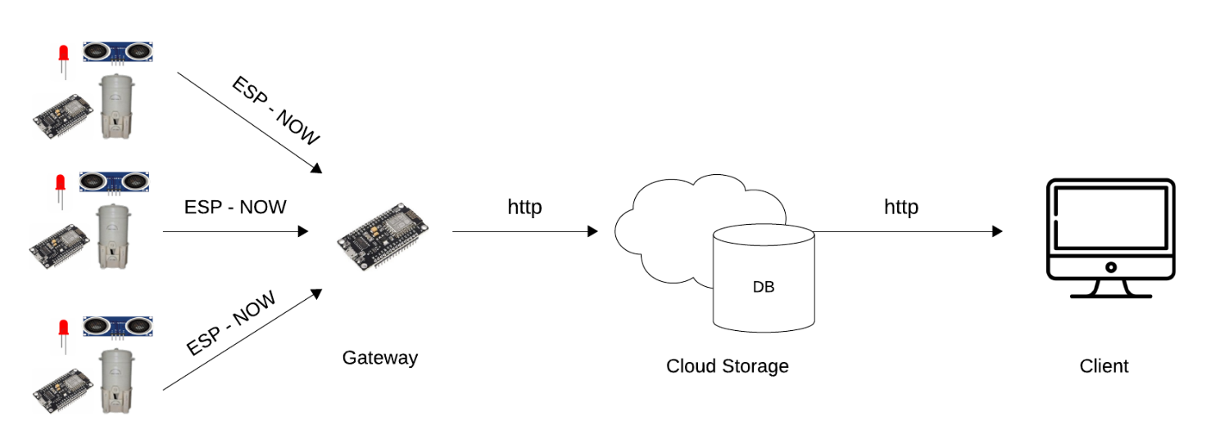

Figure 2.1 – System Architecture

# CHAPTER 3- PROJECT IMPLEMENTATION

## **3.1 Project Outcomes**

The dynamic behavior of the system is as follows:

1-The ultrasonic sensor will continuously read the water level in the water container. If the level is below a certain threshold, the LED will turn on; otherwise, the LED remains off.

2-The dashboard on the client receives water level readings. If it detects a level lower than a certain threshold, an alarm will appear on the dashboard; otherwise, the dashboard will appear normally.

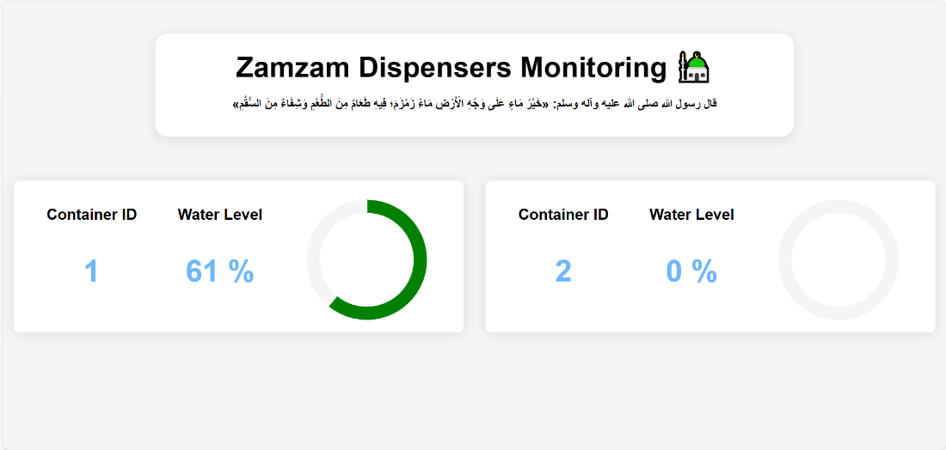

Figure 3.1 - Client UI

## **3.2 Project Implementation**

3.2.1 Sensor Node

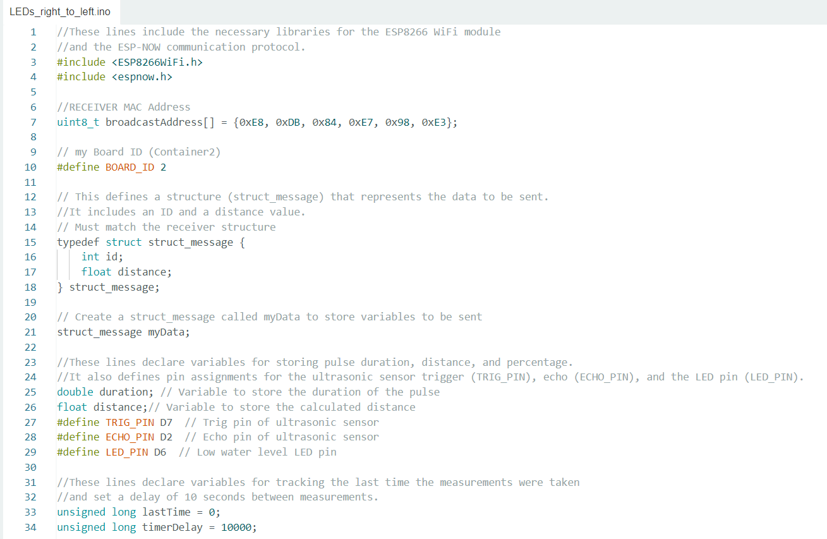

Figure 3.2 (a) – Sensor Node Code

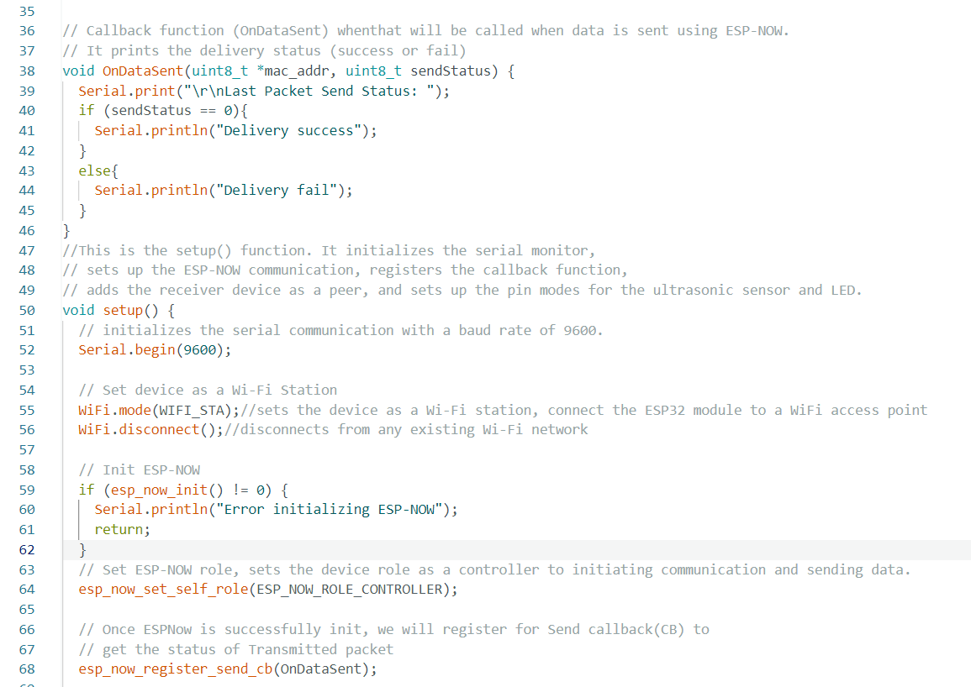

Figure 3.2 (b) – Sensor Node Code

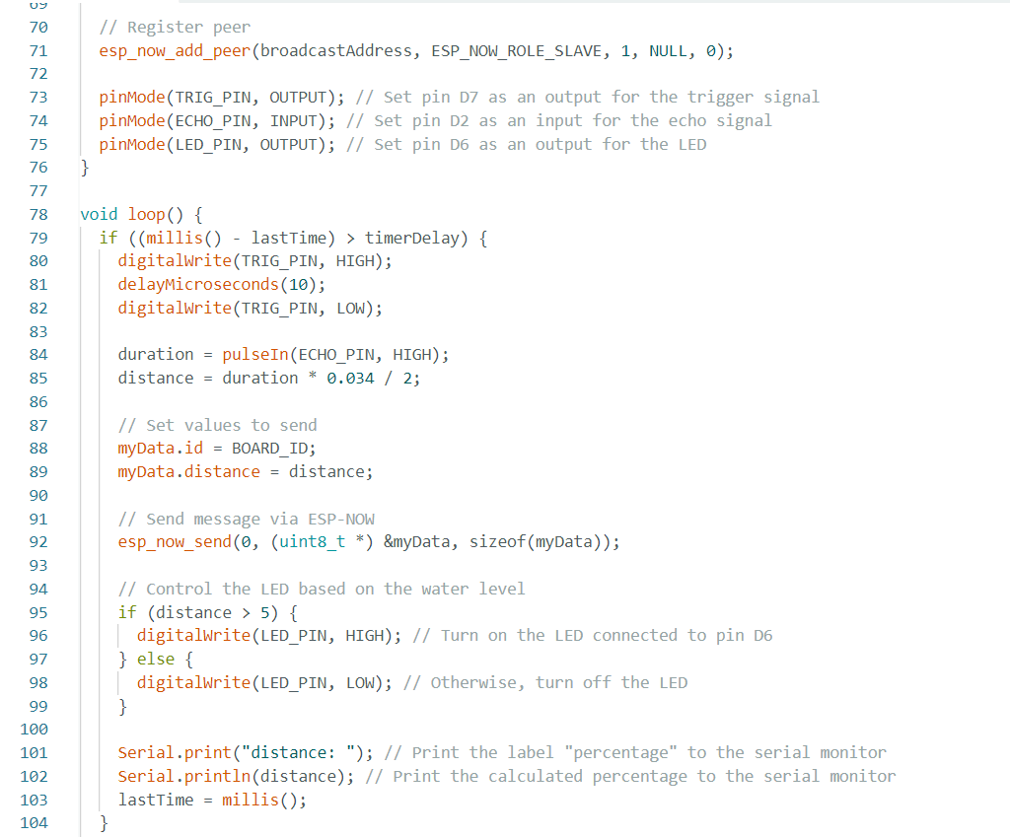

Figure 3.2 (c) – Sensor Node Code

3.2.2 Gateway

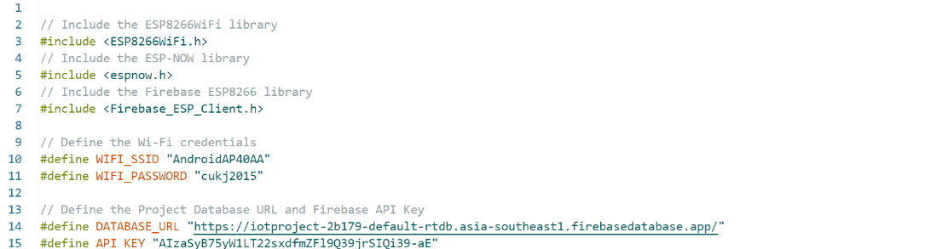

Figure 3.3 (a) – Gateway Code (Project Libraries)

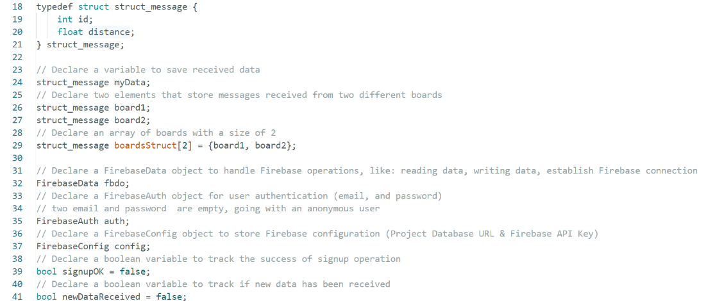

Figure 3.3 (b) – Gateway Code (Variable Declaration)

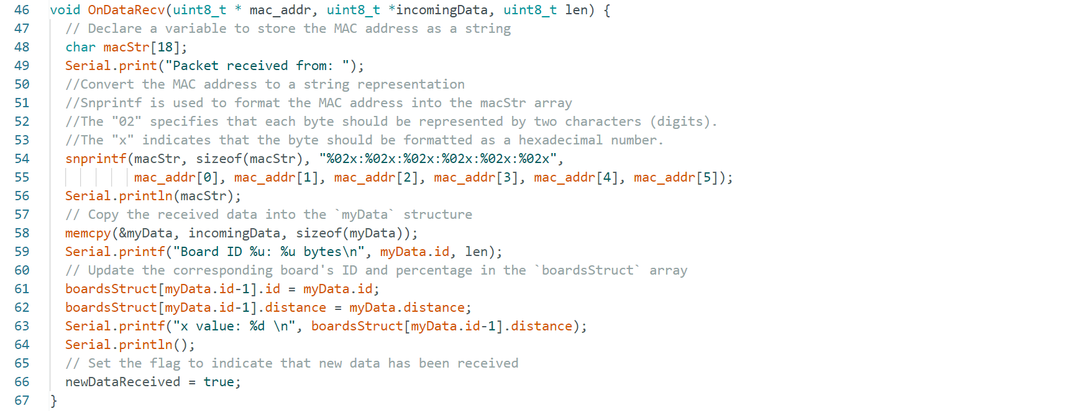

Figure 3.3 (c) – Gateway Code (Callback Function)

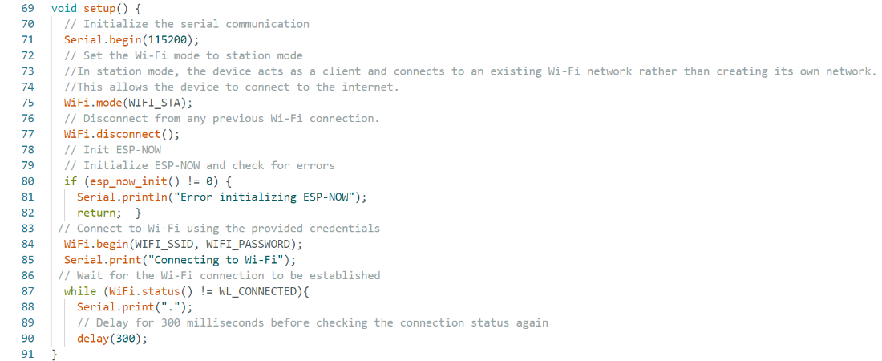

Figure 3.3 (d) – Gateway Code (setup Function -1)

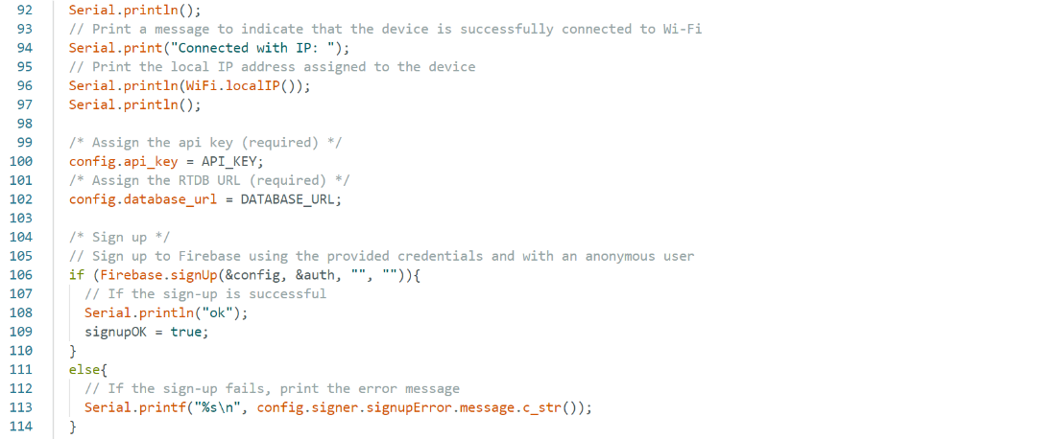

Figure 3.3 (e) – Gateway Code (setup Function -2)

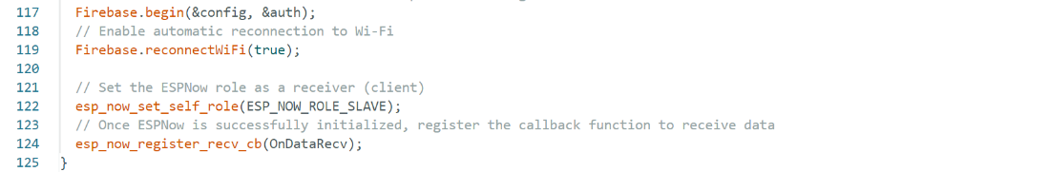

Figure 3.3 (f) – Gateway Code (setup Function -3)

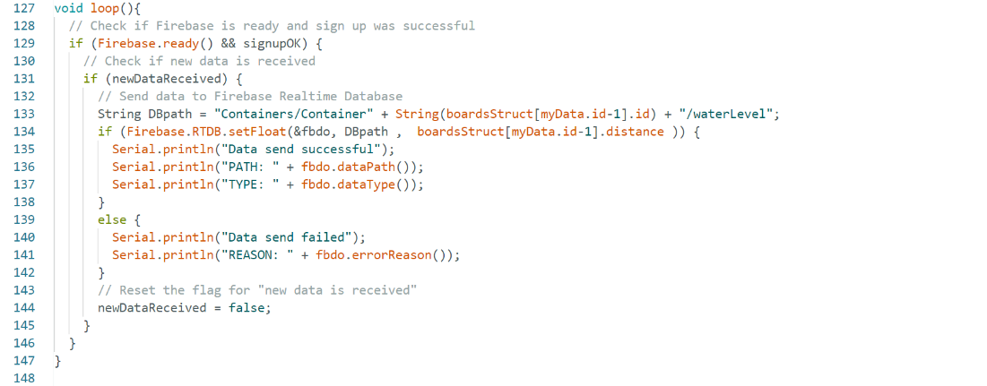

Figure 3.3 (g) – Gateway Code (Loop Part)

3.2.3 Client

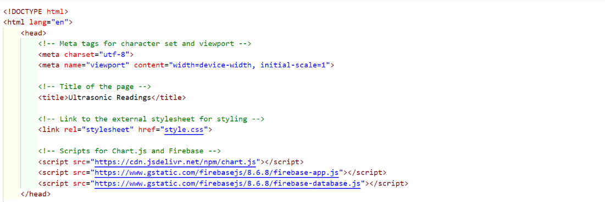

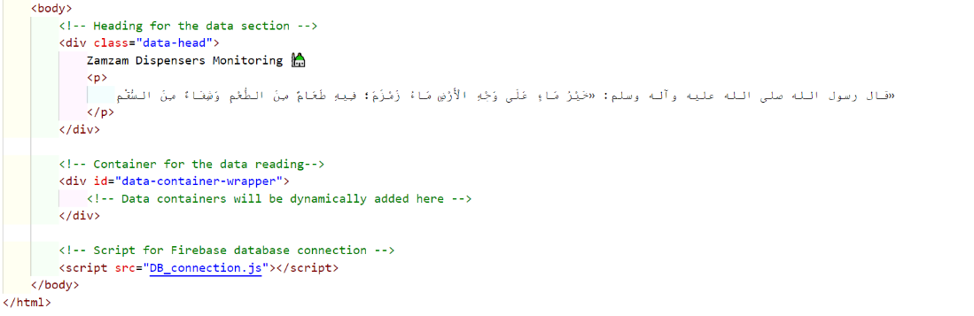

Figure 3.4 (a) - Client Code

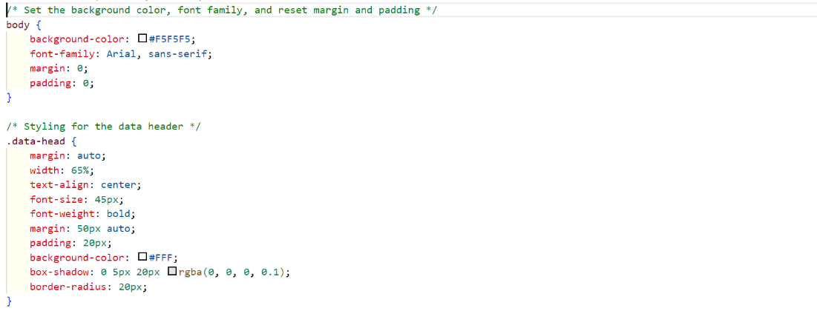

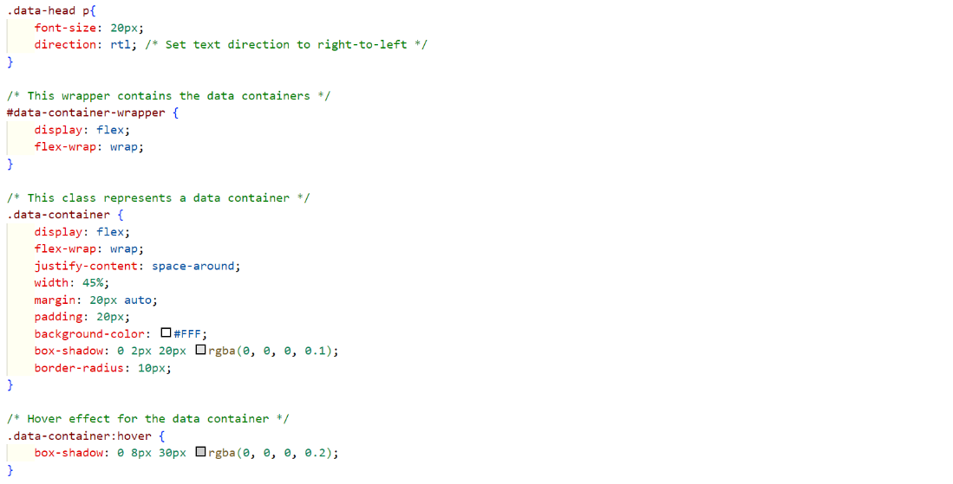

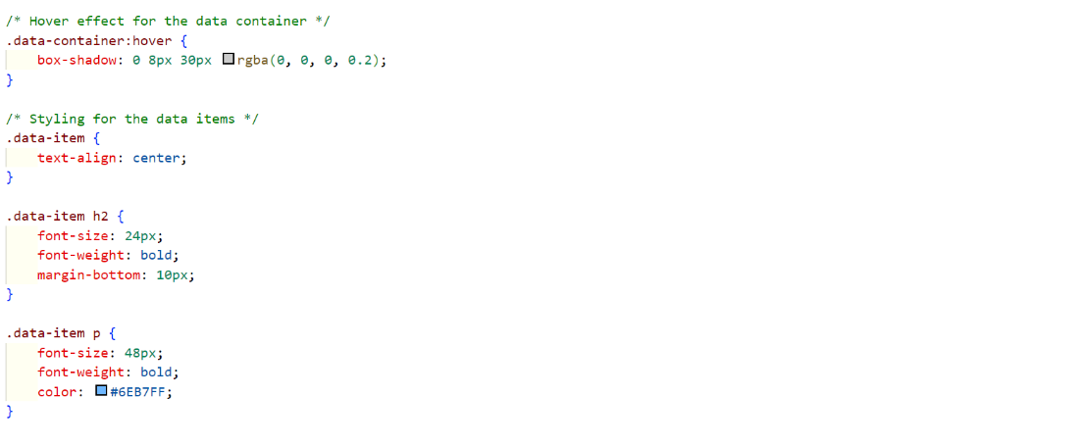

Figure 3.5 (b) - Client Code

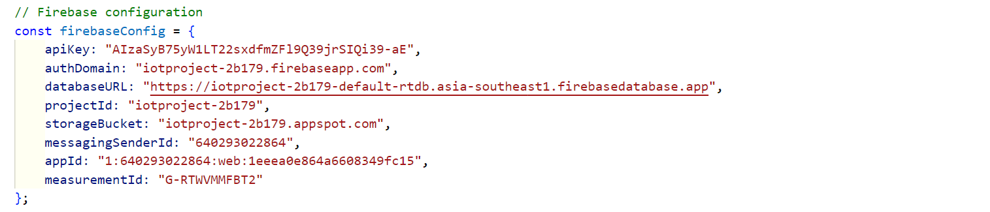

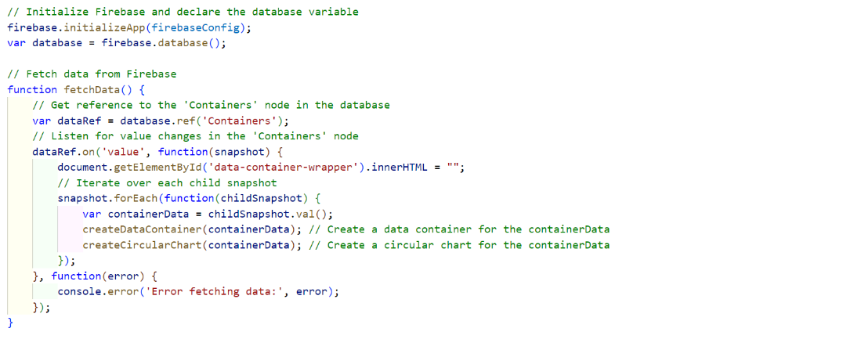

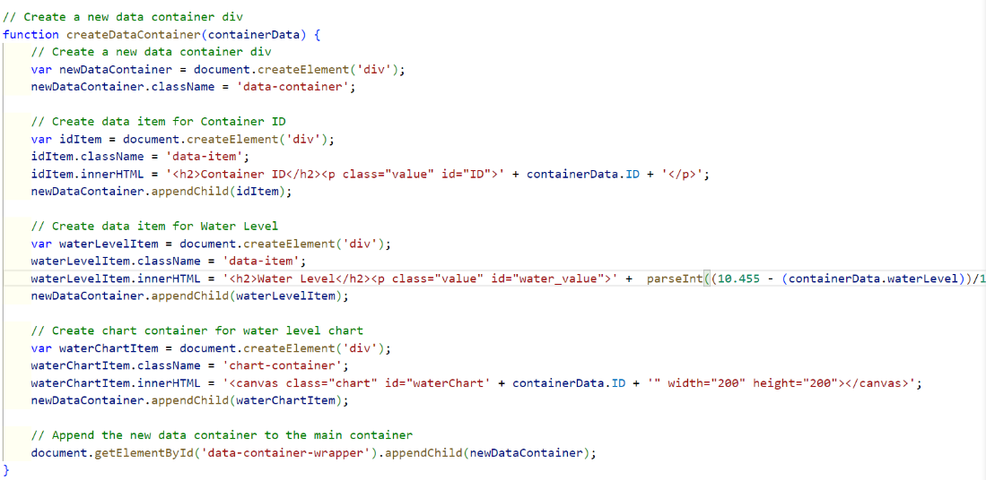

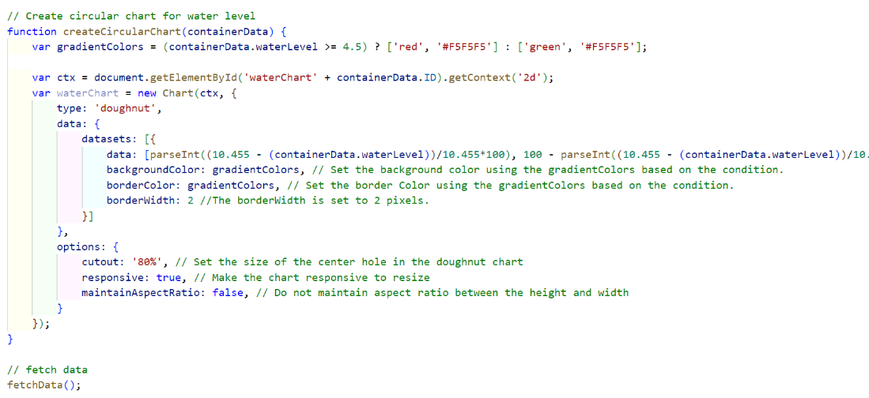

Figure 3.6 (c) - Client Code

# CHAPTER 4 - CONCLUSION

## **4.1 Summary**

In conclusion, we applied our knowledge of the Internet of Things to our project. We began by searching and reading about different sensors, microcontrollers, and protocols that could help us in the project; ultimately, we chose to use an ultrasonic sensor, LEDs as actuators, ESP8266 as a microcontroller, and ESP NOW and HTTP as protocols. Many reasons for these choices are mentioned in the report.

Throughout the project, we applied the techniques and concepts learned in our lectures, enhancing our understanding through hands-on application. Towards the end of the project, we now feel confident in determining when to use which IoT component architecture and where. Overall, this project provided us with practical experience and solidified our understanding of the course material.

**Reference**

[1] “ESP-NOW: Receive Data from Multiple ESP8266 Boards (many-to-one) | Random Nerd Tutorials,” Jun. 12, 2020. <https://randomnerdtutorials.com/esp-now-many-to-one-esp8266-nodemcu/> (accessed Dec. 09, 2023).

[2] “ESP8266: Getting Started with Firebase (Realtime Database) | Random Nerd Tutorials,” Sep. 18, 2021. <https://randomnerdtutorials.com/esp8266-nodemcu-firebase-realtime-database/>

[3]“How to get Realtime Data from Firebase to your Web Application,” www.youtube.com. <https://www.youtube.com/watch?si=rvQKDiSTAZys7pni&v=B10HWeXouIg&feature=youtu.be> (accessed Dec. 09, 2023).

‌